**EXHIBIT B**



Title of the Work

Project Title

“_________________________________________________________________________”

The following is an Exhibit marked as Exhibit “B” referred to in the Statutory Declaration of Ali bin Abu (NRIC No.: 123456-78-9999) affirmed before me on XX/XX/202X.

Before me,

…………………………………………

(Signature of Sessions Court Judge,

Magistrate, Commissioner for Oath

or notary public)

**Abstract**

On the Insert tab, the galleries include items that are designed to coordinate with the overall look of your document. You can use these galleries to insert tables, headers, footers, lists, cover pages, and other document building blocks. When you create pictures, charts, or diagrams, they also coordinate with your current document look. You can easily change the formatting of selected text in the document text by choosing a look for the selected text from the Quick Styles gallery on the Home tab. You can also format text directly by using the other controls on the Home tab. Most controls offer a choice of using the look from the current theme or using a format that you specify directly. To change the overall look of your document, choose new Theme elements on the Page Layout tab. To change the looks available in the Quick Style gallery, use the Change Current Quick Style Set command. Both the Themes gallery and the Quick Styles gallery provide reset commands so that you can always restore the look of your document to the original contained in your current template. On the Insert tab, the galleries include items that are designed to coordinate with the overall look of your document. You can use these galleries to insert tables, headers, footers, lists, cover pages, and other document building blocks. When you create pictures, charts, or diagrams, they also coordinate with your current document look. You can easily change the formatting of selected text in the document text by choosing a look for the selected text from the Quick Styles gallery on the Home tab. You can also format text directly by using the other controls on the Home tab. Most controls offer a choice of using the look from the current theme or using a format that you specify directly. To change the overall look of your document, choose new Theme elements on the Page Layout tab. To change the looks available in the Quick Style gallery, use the Change Current Quick Style Set command. Both the Themes gallery and the Quick Styles gallery provide reset commands so that you can always restore the look of your document to the original contained in your current template. On the Insert tab, the galleries include items that are designed to coordinate with the overall look of your document. You can use these galleries to insert tables, headers, footers, lists, cover pages, and other document building blocks.

## 1.0 Background of the Invention

Please use this style of formatting to ensure the report submitted is standardized. Spacing should be double.

Start here…...

## 1.0 Impact to Society

Start here…...

## 2.0 Summary of the Invention

As shown in Equation (1.1), all equations must be systematically numbered. To insert any equation, copy the whole equation and numbering below and paste on your desired location. After that, edit the equation.

|  |  |
| --- | --- |
|  | (1.1) |

To create a new report based on this template, just double click the file. A new document will open in Microsoft Word, normally named Untitled.docx. You can start put your content in that file without having to worry about the thesis formatting. However, if you want to apply this dotx template to your current thesis, you need to enable the Developer Tab option. To do so, please refer to Figure 1.

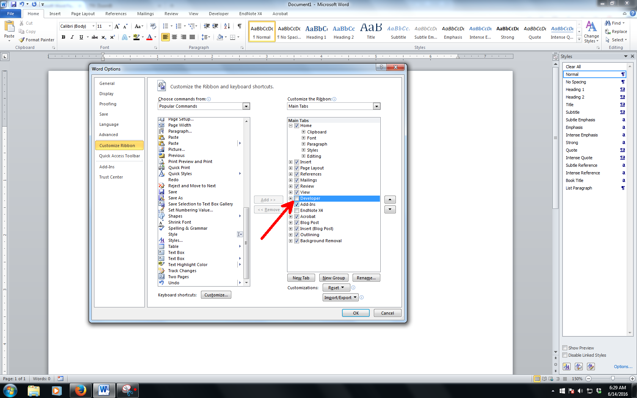

Figure 1 Enabling the Developer Tab

The basic of applying template is Styles. Styles is predefined formatting of text and paragraph. It is most efficient that you put the Styles pane on the right side of the Microsoft Word working environment by click a small arrow. If your pane is floating, click and hold the windows and put it at the right side of the windows.

## 3.0 Detailed Description of The Preferred Embodiments

To insert a quote like this, the sentences should be italic. Please ensure all quotation are properly cited.

*On the Insert tab, the galleries include items that are designed to coordinate with the overall look of your document. You can use these galleries to insert tables, headers, footers, lists, cover pages, and other document building blocks.*

The text in paragraph can be formatted. On the other hand, the style for table’s caption is as below.

Table 1 Sample table.

|  |  |
| --- | --- |
| Test | Text |
| Test | Text |
| Test | Text |
| Test | Text |
| Test | Text |

## 4.0 Conclusion

Start here…...

Appendix A  
Sample Appendix 1

For Appendices Heading use Title At Roman Pages style.